What is Marketing? How Marketing Works? What is Digital Marketing?
1. Two Daily Apps and Their Marketing Strategies
App | Marketing Strategy | Description
Instagram | Personalized Content & Reels | Instagram recommends Reels, posts, and ads based on user interests and browsing history. This keeps users engaged for longer periods.
Zomato | Push Notifications & Discount Offers | Zomato sends notifications about food discounts, free delivery, and special offers to encourage users to place more orders.

2. Poster for a New Food Delivery Service
FoodExpress – Fresh Food Delivered Fast
🍔 FoodExpress
Delicious Food at Your Doorstep!
- 🍕 Fast Delivery in 30 Minutes
- 🎉 30% OFF on Your First Order
- 🚚 Free Delivery on Orders Above ₹299
- 📱 Order Easily Through Our Mobile App
Digital Marketing Channel Used: Instagram Ads
We will promote FoodExpress through Instagram Ads because many young people use Instagram daily. Attractive food photos, short Reels, and limited-time offers will help attract more customers.
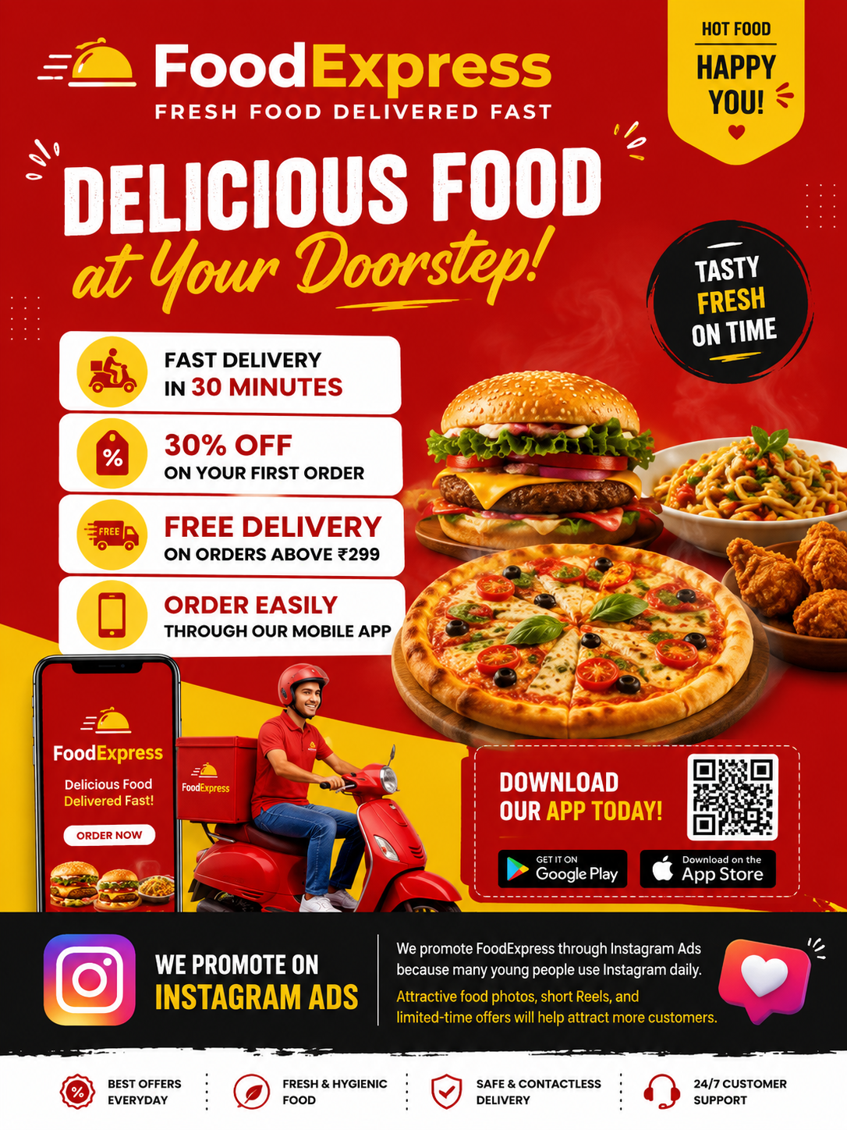

3. Traditional Marketing vs Digital Marketing
Traditional Marketing | Digital Marketing
Newspaper advertisements | Social media advertisements
Flyers and brochures | Email marketing
Television advertisements | Google Ads
Difficult to measure results | Easy to track performance using analytics
More expensive | Cost-effective and budget-friendly

4. Digital Marketing Plan for a New Spotify Playlist Feature
Marketing Plan
Spotify is launching a new feature called Smart Mood Playlist for college students.
- Promote the feature using Instagram Reels showing students enjoying music while studying and traveling.
- Run YouTube ads highlighting the benefits of personalized playlists.
- Collaborate with popular student influencers to review the feature.
- Share funny memes related to music on social media to increase engagement.
- Offer a free one-month premium trial for students who try the new playlist feature.
- Use email marketing to inform existing users about the new feature and its benefits.

Conclusion
Marketing helps businesses promote products and attract customers. Digital marketing uses online platforms such as social media, websites, and email to reach a wider audience more effectively and at a lower cost than traditional marketing.

